Module 1

Assignment 1.2
Course: CSD420-340A Advanced Java for Programmers
Prepared By: Mirach Erkol
Date of Report: 11/29/2025

https://github.com/Mikey5007/csd-420.git

1.2 Assignment:

Screenshot of GitHub repository
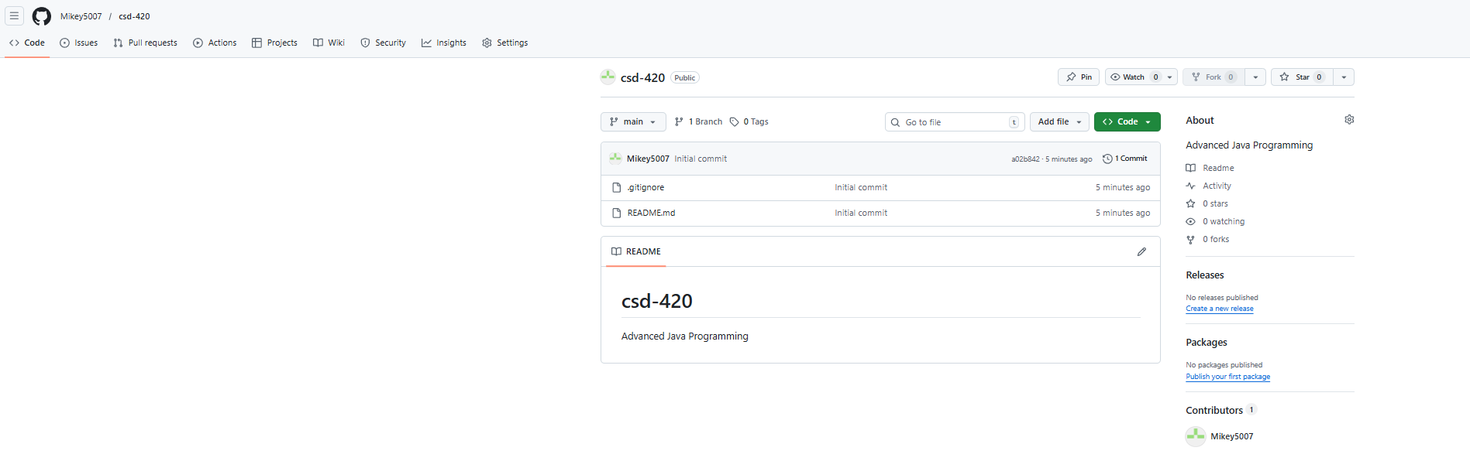
Cloned repository
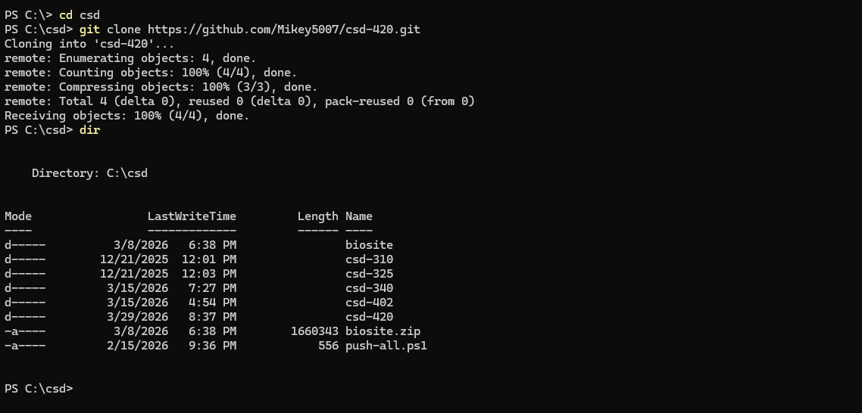

References:

https://github.com/Mikey5007/csd-420.git

